Royal College of General Practitioners
Yorkshire Faculty

MRCGP Preparation Course
2005 Version

Paper 2

PART II (at the preparation course)

- Make sure that your name is on the top of this front cover

- There are 100 questions (50 questions now and 50 to take home with you to practice)

- You have 40 minutes (<60 seconds for each question)

- Answer all questions

- When marking the paper give yourself one mark for any correct answer and no marks for an incorrect answer. There is no negative marking

From the following list of cardiac problems, choose one that matches the electrocardiograms below. Each option can be used once, more than once or not at all.

A atrial myxoma
B pulsus paradoxus
C acute inferior myocardial infarction
D left anterior hemiblock
E complete heart block
F second degree heart block
G atrial flutter
H atrial fibrillation
J ventricular bigeminy
K ventricular fibrillation
L ventricular tachycardia
M normal

- ………………………
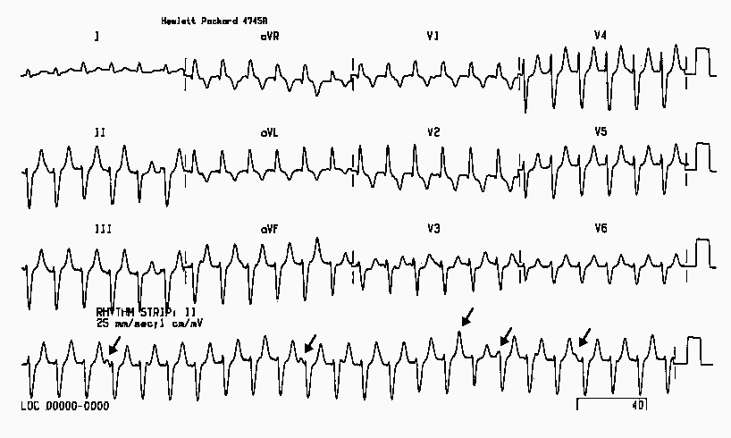

- ……………………….
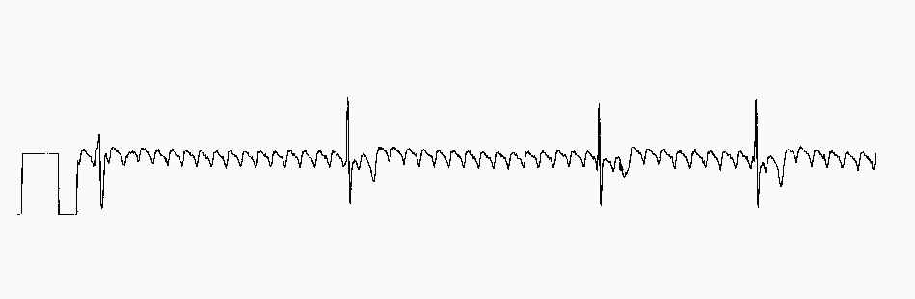

- ……………………..

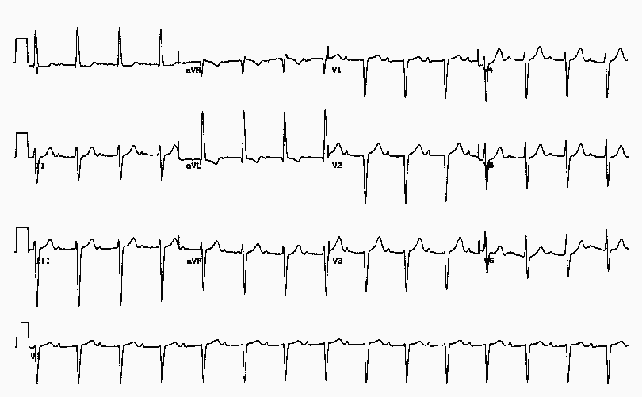

The following list are possible gynaecological pathologies

A - Fibroids
B - Pelvic Inflammatory disease
C - Endometriosis
D - Polycystic Ovary Syndrome
E - Turner’s syndrome
F - Ovarian carcinoma
G - Premenstrual syndrome

For the clinical summary below choose from the list above the most likely cause. Each option may be used once, more than once or not at all

- A 35 year old nulliparous woman with heavy painful periods responding poorly to mefenamic acid and tranexamic acid.

……………………………

- An overweight 25 year old woman with problems of subfertility and oligomenorrhoea

…………………………..

- A 45 year old lady with a 5 year history of increasingly heavy but fairly regular periods and a pelvic mass of size equivalent to a 12 week pregnancy

………………………….

According to Immunisation Against Infectious Disease (1996 HMSO), one of the following conditions is a contraindication to immunisation. Which is it?
A cerebral palsy and pertussis
B acute upper respiratory tract infection but without fever or systemic upset
C current treatment with antibiotics
D hypersensitivity to egg and influenza vaccine
E a strong family history (two first degree relatives) of inflammatory bowel disease and MMR

- …………………………………….

A 50 year old woman presents to you in morning surgery with a 6 hour history of vomiting and abdominal pain. The vomiting started at about the same time as the pain. She has had no diarrhoea. On examination, she looks in pain and unwell. Her pulse is 98 per minute, her BP 90/60. She has a temperature of 37⁰C. She is tender in the upper half of her abdomen, particularly on the right hand side. She has never had this before. What is the most likely diagnosis?
A cholelithiasis
B pancreatitis
C acute cholecystitis
D ruptured abdominal aortic aneurysm
E gastroenteritis

- …………………………………………

Choose one of the options below to describe the effects of the following drugs in pregnancy. Each option may be used once, more than once or not at all.
A a problem in the first trimester
B a problem in the second trimester
C a problem in the third trimester
D no known problem in pregnancy
E a problem in more than one trimester

- penicillin

…………………………….
- diclofenac

……………………………
- trimethoprim

………………………….
- cetirizine

……………………………
- lansoprazole

…………………………..

A 38 year old woman has endometriosis and is symptomatic. She is nulliparous, and does not want a pregnancy at the present time. She is underweight and a smoker of 25 cigarettes per day. Choose the most appropriate medication for treatment from the list below.

A finasteride
B tibolone
C nafarelin
D combined oral contraceptive
E Danazol

- ……………………………………

Choose three of the following eight statements that are true
according to the ALLHAT study (Antihypertensive and Lipid Lowering Treatment to Prevent Heart Attack) published in JAMA in Dec. 2002

A chlorthalidone was superior to amlodipine at preventing cardiovascular events
B the amlodipine arm of the study was stopped due to a higher rate of heart failure
C doxazosin was superior to chlorthalidone at preventing cardiovascular events
D the patients receiving lisinopril had better blood pressure control than patients in any other treatment group
E the effectiveness of chlorthalidone compared to lisinopril was more remarkable in blacks than in non-blacks
F the trial was randomised but not ‘blinded’
G amlodipine and chlorthalidone had lower rates of cardiovascular events than doxazosin and lisinopril
H the study recruited over 450,000 patients in North America

- …………………………………………..

- …………………………………………….

- …………………………………………..

Choose one of the following options in the management of hypertension, for each of the clinical scenarios. These options are in line with guidelines issued by Prodigy, which is a combination of the British Hypertension Society guidelines of 1999, National Service Framework for coronary heart disease,

A 5-yearly follow-up (annually if arterial disease)
B Repeat 2-monthly for 6 months and treat depending on risk score
C Repeat monthly for 3 months and treat if sustained.
D Repeat weekly over 3 weeks and treat if sustained.
E Repeat on same day and treat immediately if confirmed.

- Systolic BP 140-159 mmHg and/or Diastolic BP 85-99 mmHg

…………………………………….
- Systolic BP 200-219 mmHg and/or Diastolic BP 110-119 mmHg

…………………………………….

In malignant melanoma
Malignant melanoma is associated with two of the following factors:

A excessive alcohol intake
B exposure to ultraviolet radiation
C Crohn’s disease
D first-degree relative with a history of basal cell carcinoma
E seborrhoeic dermatitis
F fair skin type

- ……………………………..

- ……………………………..

Each of the following skin conditions has a typical distribution. For the parts of the body listed below, choose the skin condition that most characteristically affects that part of the body

A epidermoid cysts
B atopic eczema
C staphylococcal boils
D lupus erythematosus
E pilar cysts
F erythema nodosum
G Bowen’s disease
H psoriasis

- Face……………………………………………………….
- Eyelids……………………………………………………
- Scrotum………………………………………………….
- Hands……………………………………………………..

Regarding the Hypertension Optimal Treatment study published in the Lancet in 1998, choose one of the following statements which bests reflects the opinions of the authors

A The study shows greater benefit in lowering systolic blood pressure than diastolic blood pressure
B The use of aspirin had no significant effect on reducing cardiovascular events
C The use of aspirin significantly reduced the incidence of stroke
D Intensive lowering of blood pressure in patients with hypertension was associated with a low rate of cardiovascular events
E The study shows unequivocally the presence of a J-shaped treatment/benefit curve in hypertension

- ……………………………………………..

According to a meta-analysis published in the Lancet (Risks of untreated and treated isolated systolic hypertension in the elderly: meta-analysis of outcome trials. Staessen JA, Gasowki J, Wang J et al; Lancet, 355: 865-872, March 2000) choose one statement that most accurately states the results

A Treatment of systolic blood pressure was more important than diastolic
B treating systolic blood pressure was equally as important as treating diastolic blood pressure
C treatment of systolic blood pressure had a positive effect on all cardiovascular outcomes
D systolic and diastolic hypertension affected only cardiovascular mortality rather than all cause mortality
E the most effective treatment for systolic blood pressure in the elderly was a betablocker

- ………………………………………………………

For the Joint British Societies coronary risk prediction chart, one of the following statements is not correct.

A This is a prediction chart fro primary prevention
B It deals in absolute rather than relative risk
C It takes into account HDL and LDL cholesterol
D One factor taken into account is the most recent blood pressure
E It does not allow for ethnicity

- …………………………………………………………
According to the Drug and Therapeutics Bulletin of December 1998, the management of acute simple back pain does NOT include one of the following options. Which option is it?

A manipulative treatment within the first 6 weeks
B an x-ray of the affected area if there is no improvement after 6 weeks
C the advice of minimal bedrest and maximal exercise
D paracetamol as first line analgesia
E referral to a specialist if the patient is not back at work within three months

- ………………………………………………………………

Of short-acting inhaled beta agonists in the treatment of asthma, choose the most accurate statement from those below.

A Regular use (four times daily) gives reductions in bronchial hyper-reactivity
B Regular use (four times daily) can give rise to pulmonary fibrosis
C Using them as needed (PRN) gives greater improvement in quality of life scores
D There is no difference in clinical benefit between using them regularly compared with ‘as needed’ (PRN)
E Regular use (four times daily) reduces the need for inhaled steroids

- …………….………………………………………….

In patients with mild persistent asthma, choose one option from the list below the most significantly improves symptoms and lung function

A regular (four times daily) inhaled short acting B₂ agonist
B PRN inhaled short acting B₂ agonist
C low dose (<500mcg) inhaled beclomethasone per day or equivalent
D placebo
E inhaled ipratropium bromide regularly (four times daily)

- ………………………..……………………………………………….

Choose the most accurate statement regarding treatment for acute but non-life-threatening asthma from the list below

A in general, nebulisers are better than spacer devices or holding chambers such as volumatic or nebuhaler
B intramuscular steroids give a significantly quicker (by 12 hours) improvement in peak expiratory flow rate than oral steroids
C systematic reviews have shown that inhaled corticosteroids are as effective as oral steroids
D intravenous salbutamol is not associated with more adverse effects than nebulised salbutamol
E adding ipratropium bromide to short acting beta₂ agonists does not affect hospital admission rates

- ………….……………………………….
On interpretation of spirometry, choose one of the following that most accurately describes that found typically in obstructive ventilatory defects

A a high FEV₁/FVC%
B a reduction in both FEV₁ and FVC
C a reduced FVC
D a low FEV₁/FVC%
E a raised FVC

- ………………………………………………………………….

Below are various arrhythmias. For each clinical condition, choose the arrhythmia(s) that are associated with that condition. For each clinical condition, there may be more than one arrhythmia.

A sinus tachycardia
B supraventricular tachycardia
C atrial flutter with block
D complete heart block
E sinus bradycardia
F atrial fibrillation
G ventricular fibrillation
H ventricular tachycardia
J ventricular asystole

- thyrocoxicosis……………………………………………………….
- excessive caffeine intake……………………………………………..
- cardiomyopathy………………………………………………………..

The following graphs represent flow-volume loops. These graphs are produced from a spirometer. For the following THREE clinical conditions, choose the most representative graph.

A B
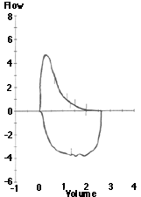

C D
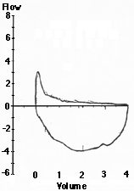
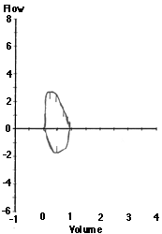

- mild obstruction………………………………………….

- severe obstruction……………………………………..

- restriction…………………………………………………….

According to the Glasgow Coma Scale, if a 21 year old man has been involved in a road traffic accident and has a scalp wound with the skull visible at the base together with the following features:
- Eyes open to pain
- He appears confused
- He tries to move your hand away when you press on his supra-orbital nerve.

His Glasgow Coma score is:

A 11

B 12

C 13

D 14

E 15

- …………………………………………………

For the following clinical scenarios choose the most appropriate seizure classification from those below:

A generalised tonic-clonic seizure
B partial seizure
C myoclonic jerks
D absence
E automatism
F status epilepticus

- A 25 year old woman who has a history of episodes of impaired consciousness. She has been described by witnesses as being vacant for around 30 seconds. She has also noticed episodes of peculiar smells and a rising sensation in her epigastrium.

…………………………………………
- A 30 year old man brought in by his wife to your consulting room with a two month history of persistent lipsmacking and tongue biting as though he is agitated in association with loss of concentration and ‘as though he is not there’

…………………………………………

- A 16 year old girl accompanied by her mother. She has had two episodes of sudden flinging out of her right arm and leg followed by falling to the floor and loss of consciousness for about 30 seconds.

……………………………………….

A 30 yr old man with no significant past medical history presents with a 6 week history of increasing frequent and severe but intermittent vertical headaches. They can waken him. They tend to get easier as the day progresses. They are intermittent. On one occasion it was sited over the right frontal and aural area and associated with vomiting and nausea. Clinical examination reveals nothing abnormal. The most likely diagnosis is:

A a cerebral space occupying lesion
B migraine
C tension headache
D benign intracranial hypertension
E glossopharyngeal neuralgia

- …………………………………………………………………….

A scleritis
B episcleritis
C acute glaucoma
D iritis
E keratitis
F conjunctivitis
G subconjunctival haemorrhage
From the above causes of a red eye choose one that corresponds most appropriately to the clinical situation described below. Each item may be used more than once or not at all.

- A fifty year old man with a vague pain in his left eye and a watery discharge. His vision is normal but he is photophobic and there are dilated blood vessels in the tarsal conjunctiva.

………………………………………..

- A 50 year old man with a painful right eye, photophobia and loss of corneal clarity

………………………………………

- A 30 year old lady with pain and photophobia in her left eye. She has a small pupil and dilated circumcorneal conjunctival vessels

………………………………..

- A 60 year old man with headache and vomiting. There is gross visual impairment with a fixed dilated right pupil and corneal oedema
………………..……………………….
- A 40 yr old woman with localised redness of bulbar conjunctiva in the left eye, normal vision but a little pain in the eye

……………………….………………………

For Prochaska and DiClemente’s model for the cycle of change (1982), label the following schematic representation:

51
Contemplation

50

52

action

- …………………………………………………………….

- …………………………………………………………….

- …………………………………………………………….

An individual’s potential to develop pressure ulcers may be influenced by the following factors:
a) acute illness
b) anaemia
c) level of consciousness
d) sensory impairment
e) vascular disease

Choose from the options below, which of the above are true
A all of the above
B a), c), and e)
C b), c), and d)
D c), d), and e)
E b), c), d) and e)

- …………………………………………………

On consulting the Mental Health Act (1983) for England and Wales, consider which individuals may be involved in each aspect of the Act.
More than one person may be required for each section of the Act. Each person may be used once, more than once or not at all.

A Any doctor
B Any doctor with prior knowledge of the patient
C Any doctor approved under section 12 of the Mental Health Act
D A police officer
E A close relative of the patient
F A magistrate
G A judge
H An approved social worker

- Section 2 of the Act allowing for compulsory admission for assessment and subsequent treatment. Who might be involved in this Section of the Act?

…………………………….………………………..

- Section 136 of the Act allowing for removal of the patient to a place of safety awaiting assessment. Who might be involved before assessment?

…………………………..………………………………….

- Section 4 of the Act allowing for compulsory admission for treatment. Who might be involved in this Section of the Act

…………………………..……………………….

According to the International Classification of Diseases (ICD-10), choose one of the following symptoms that is most typical of depression

A derealisation
B depersonalisation
C diarrhoea
D 3rd person auditory hallucinations
E visual hallucinations

- ……………………………………………….

Which of the following statements about depression is most accurate?

A Genetic influences are stronger in patients with more severe bio- logical symptoms than in those without.
B In monozygotic twin studies of bipolar disorder the concordance rate is around 10%
C Loss of a parent before the age of 11 years has no effect on the incidence of depression in later life
D Unemployment does not adversely affect a patient’s response to a life event
E The presence of more than three young children in the home is typically beneficial

- ……………………………………..

Choose one of the following factors which is a good prognostic indicator in schizophrenia

A poor work record
B gradual onset
C catatonic symptoms
D flattening of affect
E visual hallucinations

- ……………………………………….

Choose one of the following statements about schizophrenia which is least likely to be correct
Schizophrenia…
A is at least partly a disorder of neurodevelopment
B in developed countries is more common in rural areas than urban areas
C tends to cause negative symptoms in men and affective symptoms in women
D causes somatic passivity according to Schneider’s first rank symptoms
E treatment should continue for at least a year after the first schizophrenic episode

- ……………………………………….

Regarding otitis media, choose three correct statements from the following

A several systematic reviews concur that both ibuprofen and paracetamol are better than placebo in symptom relief
B in the majority of children the condition resolves in about 3 days without antibiotic treatment
C antibiotics improve pain within 24 hours
D systematic reviews clarify the fact that amoxycillin should be the first line antibiotic when antibiotics are considered necessary
E the most common bacterial causes are strep pneumonia, haemophilus influenzae and moraxella catarrhalis
F antibiotics do not have an influence on subsequent deafness from acute otitis media
G a systematic review supports the use of a ten day course of antibiotics compared with 5 days because of less long term (28-42 days) recurrence

- …………………………………
- ………………………………..
- …………………………………..

From the following possible nerve supplies, choose the one that is the most appropriate for the muscle movement listed below. Each option can be used once, more than once or not at all.
A 2nd cranial nerve
B 3rd cranial nerve
C 4th cranial nerve
D 5th cranial nerve
E 6th cranial nerve
F 7th cranial nerve
G C5/C6
H C7/C8
J T1
K L1
L L2/L3
M L3/L4
N L4/L5
P S1/S2

- moving the eye laterally and down

…………………………………………….
- moving the eye upwards and medially

…………………………………………….
- using the muscles of mastication

……………………………………………..
- pronation of the forearm

……………………………………………….
- abduction of the fingers

…………………………………………….
- ankle dorsiflexion

……………………………………………..

The most likely cause of jaundice in the first 24 hours after birth is:

A kernicterus
B haemolytic disease due to Rhesus iso-immunisation
C breast milk jaundice
D physiological jaundice
E galactosaemia

- ………………………………………

In routine immunisation procedures in the UK, which vaccines are given at the age of 16 weeks.

A diphtheria, tetanus, pertussis, polio, measles, mumps, rubella
B diphtheria, tetanus, polio, measles, mumps, rubella
C diphtheria, tetanus, pertussis, meningitis C, polio
D diphtheria, tetanus, pertussis, polio, haemophilus influenzae B
E diphtheria, tetanus, pertussis, polio, haemophilus influenzae B & meningitis C

- ………….………………………….

Below is a list of possible incubation periods. Choose the most appropriate incubation period for measles.

A 2-5 days
B 5-10 days
C 7-14 days
D 10-21 days
E upwards of 21 days

- …………………………………………

In patients with obstructive sleep apnoea which of the following statements is untrue

A narrowing or collapse of the upper airway during sleep is the cause
B the majority of patients are obese with a body mass index >30kg/m²
C there may be associated poor short term memory
D nasal CPAP is an effective treatment
E palatal surgery has no place in the management

- …………………………………………………

Which of the following diseases are not notifiable to the Public Health department

A psittacosis
B rubella
C food poisoning
D measles
E rabies

- ………………………………………………

Below is a list of possible diseases. For the laboratory results below, choose the most likely diagnosis. Each diagnosis may be used once, more than once or not at all

A acute pancreatitis
B Paget’s disease of bone
C Hepatitis A
D prostatic carcinoma
E myocardial infarction
F chronic renal failure
G cirrhosis of the liver
H bony metastases

Test | Result | Normal range
Alanine transaminase (ALT) | 723 | 3-60
Aspartate transaminase (AST) | 524 | 3-60
bilirubin | 81 | 1-20

- …………………………………………………

Test | Result | Normal range
Alanine transaminase (ALT) | 120 | 3-60
Aspartate transaminase (AST) | 400 | 3-60
bilirubin | 24 | 1-20

- …………………………………….

Below are clinical scenarios describing symptoms in the neck. Choose the most likely cause from those following

A pyogenic cervical spondylitis
B Klippel-Feil syndrome
C Sprengel’s shoulder
D cervical rib
E infantile torticollis
F prolapsed cervical disc
G ankylosing spondylitis
H cervical spondylosis (osteoarthritis)

A 51 year old man with aching in the back of the neck and trapezius area for the last month with stiffness of the neck particularly in the morning. He is otherwise well

- ……………………………………….

A 49 year old woman with a one week history of pain and stiffness in the neck following a fall in the snow. She also has a severe pain in the whole of her left arm. Lateral flexion is normal but other movements are limited by pain

- …………………………………………

Please read the following extract from a paper published in the British Medical Journal in July 2002.
(Predictors of poor outcome and benefits from antibiotics in children with acute otitis media: pragmatic randomised trial BMJ 2002;325:22)

Methods
This study was part of a pragmatic randomised controlled trial of two prescribing strategies for acute otitis media, the methods of which have previously been reported in full.

Sample
The participants were children aged 6 months to 10 years who were brought to their general practitioner with acute otalgia and otoscopic evidence of acute inflammation (dullness, cloudiness, erythema or bulging, perforation). When children were too young for otalgia to be documented from the history (under 3 years old) otoscopic evidence only was sufficient. Coloured photographs were provided to guide general practitioners in diagnosis.

Exclusion criteria were otoscopic appearance consistent with crying or fever alone (pink drum); appearance and history more suggestive of otitis media with effusion and chronic suppurative otitis media; serious chronic disease (for example, cystic fibrosis, valvular heart disease); use of antibiotics for ear infections within the previous two weeks; previous complications (septic complications, hearing impairment); child too unwell to be left to wait and see (very unwell systemically with high fever, floppy, drowsy, not responding to antipyretics).

We calculated the sample size for 80% power and 95% confidence using the Nquery sample size program. To detect a risk factor with an odds ratio of 2.5 for poor outcome where a minority of children suffer poor outcome (25%) and where between 33% and 66% of children have the risk factor required data from 280 children.

A pragmatic study in this context means
A realistic
B optimistic
C idealistic
D randomised
E free of bias

- …………………………………………..

Coloured photographs were an effort to improve
A bias
B blinding
C precision
D inclusion criteria
E generalisability

- ……………………….…………………

The exclusion criteria noted will reduce the
A generalisability
B sensitivity
C specificity
D reliability
E validity

- ……………………………………………..
Increasing the sample size from 280 children will of necessity increase
A standard deviation
B power of the study from 80% if the confidence limits remain the same
C standard error
D the percentage of children suffering a poor outcome
E the odds ratio

- …………………….……………………….

Acute severe abdominal pain, no abdominal signs and rapid hypovolaemic shock is most typical of which of the following abdominal problems

A acute small bowel ischaemia
B acute appencitis
C ascending cholangitis
D acute cholecystitis
E ruptured spleen

- …………………………………………

Which of the following risk factors are not associated with breast cancer

A multiparity
B first pregnancy >30 years old
C early menarche
D late menopause
E BRCA genes

- …………………………………………….

From the following vocabulary of drug users, choose one term that is most likely associated with the drugs below:

A Billy
B poppers
C snappers
D Charlie
E scag
F echo
G Mary
H Mud
J angel dust

- amphetamines

……………….……………………..
- cocaine

…………………………………………
- methadone

……………………………………

From the following possible diagnoses, choose one cause that is most likely to give a normocytic anaemia

A thalassaemia
B chronic renal failure
C liver disease
D haemolytic anaemia
E hypothyroidism

- ……………………………………………….

Below is a list of possible descriptions of a peripheral blood film. Choose the most appropriate description to be found for the diseases below

A basophilic stippling
B Howell-Jolly bodies
C normoblastosis
D poikilocytosis
E reticulocytosis
F hypochromia
G hypersegmented polymorphs
H rouleax formation
J target cells

- any condition with a high ESR

………………………………….
- hyposplenism

………………………………..
- uraemia

……………….………………

The following is an example of a trial profile. This was a randomised controlled trial comparing satisfaction (by questionnaire) and several other parameters of care between nurse practitioners and general practitioners.

Eligible patients
682

Excluded patients for
- Critical illness
- Seen in previous two weeks
- Refusal to take part
98

Recruited patients
584

Patient randomised to see doctor
290
Patient randomised to see nurse
294

Patient changed mind and wished to see doctor
24
Patient changed mind and wished to see nurse
2

Patients consulting doctor
312
Patient consulting nurse
272

Patients consulting doctor and completed a questionnaire
203
Patients consulting nurse practitioner and completed a questionnaire
208

If we were to analyse this study by intention to treat, then we would use the following figures

A 208 & 312
B 294 & 290
C 312 & 272
D 272 & 203
- ……………….……………………..

If we were to analyse this study by on treatment, then we would use the following figures
A 208 & 312
B 294 & 290
C 312 & 272
D 272 & 203
- …………………..…………………..

Which of the following would have the effect of increasing the required sample size for a randomized study examining the effects of treatment between a treatment group and a control group

A increasing the treatment differences to be detected between the two groups
B increasing the type II error which is the chance of a false-negative result
C increasing the type I error which the chance of a false-positive result
D increasing the size of the confidence interval between the confidence limits
E reducing the power of the study from 90% to 80%

- …………………..……………………………….

Which of the following list would usually give the weakest method of random sampling?

A systematic assignment
B simple randomisation
C permuted blocks
D stratified randomisation
E unequal randomisation in a ratio of 2:1

- …………………………………………….
When considering the combined oral contraceptive, which of the following symptoms would not contra-indicate the pill in relation to migraine aura?

A homonymous hemianopia
B teichopsia
C bright scotoma
D nominal dysphasia
E photophobia

- ………………………………………….

Below is a list of possible changes to the combined oral contraceptive. For the following side effects choose the most appropriate option to reduce the side effect

A reduce oestrogen or increase progestogen
B increase oestrogen or reduce progestogen
C reduce progestogen and oestrogen
D increase progestogen and oestrogen

- Nausea

………………………………..
- Loss of libido

……………….………………..
- Acne

……………..………………….

The following is a drawing of an eye. From the list below, what is the most likely diagnosis?

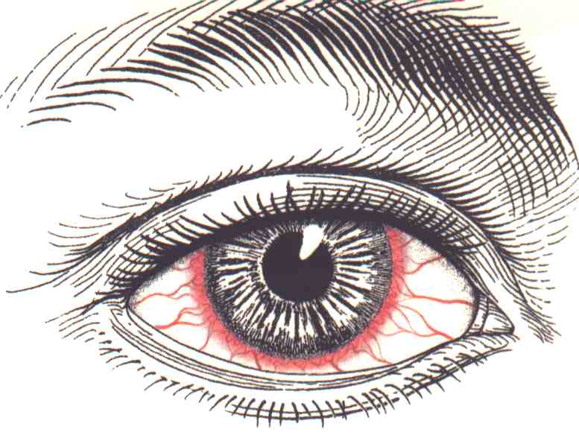

A iritis
B hypopyon
C marginal corneal ulcer
D acute viral conjunctivitis
E blepharitis

- ……………………………………..

